Q: 1)What does the len() function do in Python? Write a code example using len() to find the length of a list.

Ans: The len() function in Python returns the number of items in an object. It can be used to find the length of various data types such as strings, lists, tuples, dictionaries, and sets.

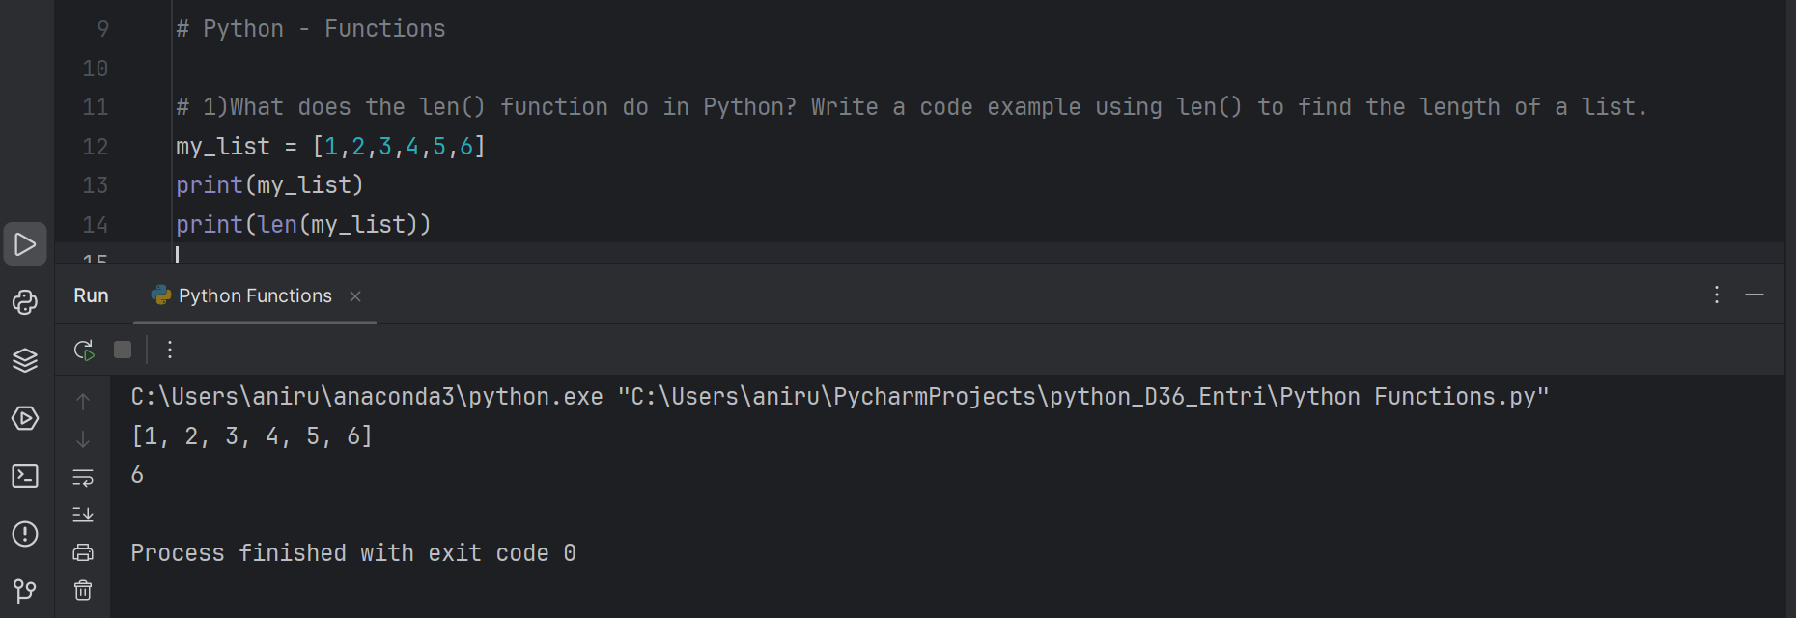

Q: 2)Write a Python function greet(name) that takes a person's name as input and prints "Hello, [name]!".

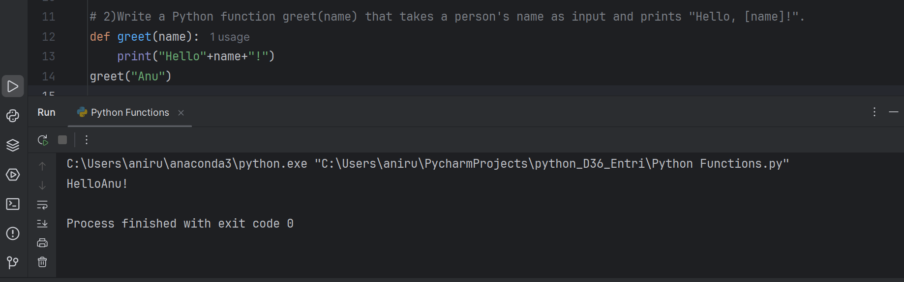

Q: 3) Write a Python function find_maximum(numbers) that takes a list of integers and returns the maximum value without using the built-in max() function. Use a loop to iterate through the list and compare values.

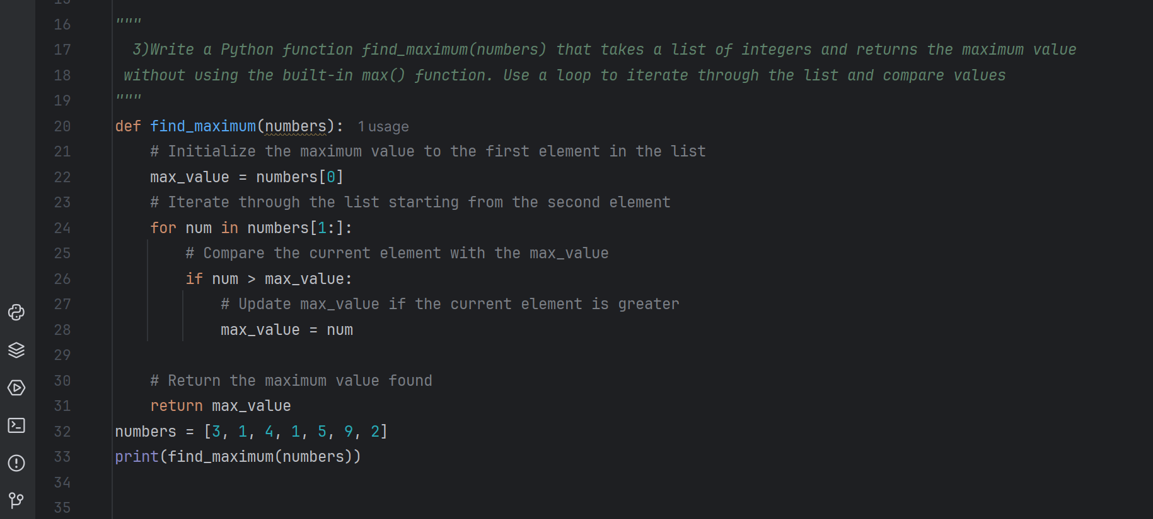

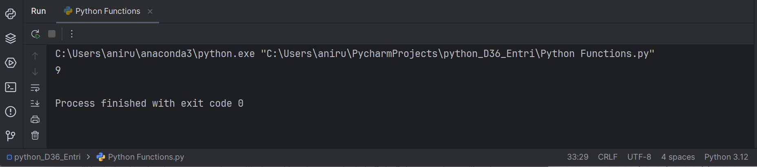

This function uses a for loop to iterate through the list, starting from the second element (index 1). It compares each element with the current max_value, and updates max_value if the current element is greater. Finally, it returns the maximum value found.

Q: 4) Explain the difference between local and global variables in a Python function. Write a program where a global variable and a local variable have the same name and show how Python differentiates between them.

Ans) Local Variables

* Defined inside a function or a block (like if, for, while)
* Only accessible within that function or block
* Created when the function is called and destroyed when the function finishes execution
* If a local variable has the same name as a global variable, the local variable hides the global variable within the function
* Can be assigned a value within the function
* Can be used as a temporary variable to store intermediate results

Global Variables

* Defined outside of any function or block
* Accessible from any part of the program
* Retains its value throughout the program's execution
* Can be accessed and modified by any function or block
* If a global variable is assigned a value within a function, it will change the global variable's value
* Can be used to store data that needs to be shared across multiple functions

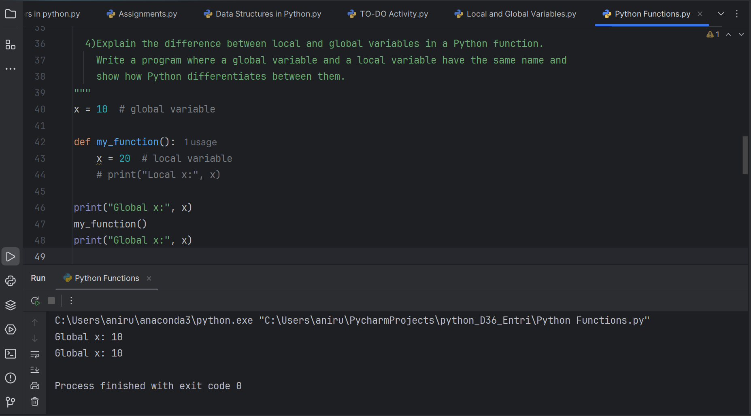

In this program, x is a global variable that is defined outside of the function my_function(). Inside my_function(), x is redefined as a local variable and assigned the value 20. When we print x inside the function, it prints the local value 20. However, when we print x outside the function, it still prints the global value 10.Python differentiates between global and local variables by using a concept called"scopes". A scope is a region of the code where a variable is defined and accessible. Global

variables are defined in the global scope, while local variables are defined in the local scope of a function.

Q: 5) Create a function calculate_area(length, width=5) that calculates the area of a rectangle. If only the length is provided, the function should assume the width is 5. Show how the function behaves when called with and without the width argument.

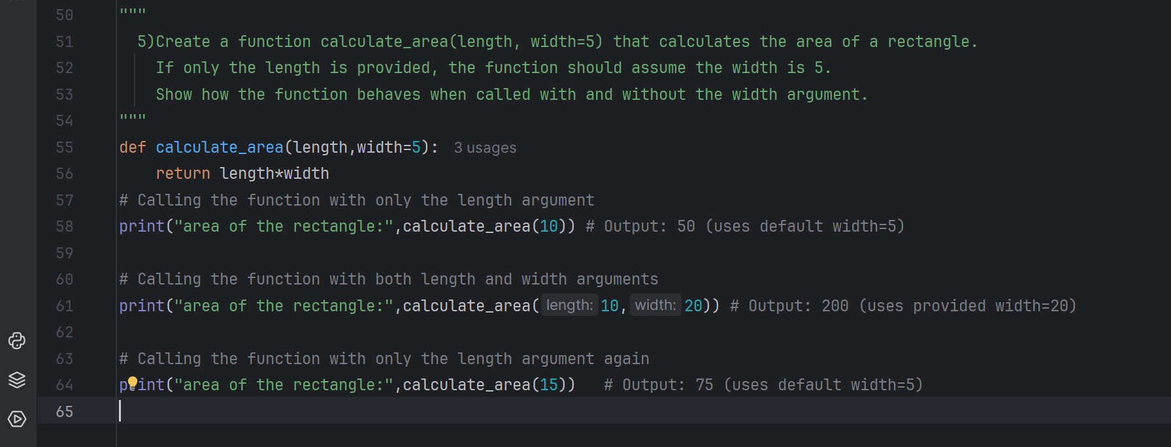

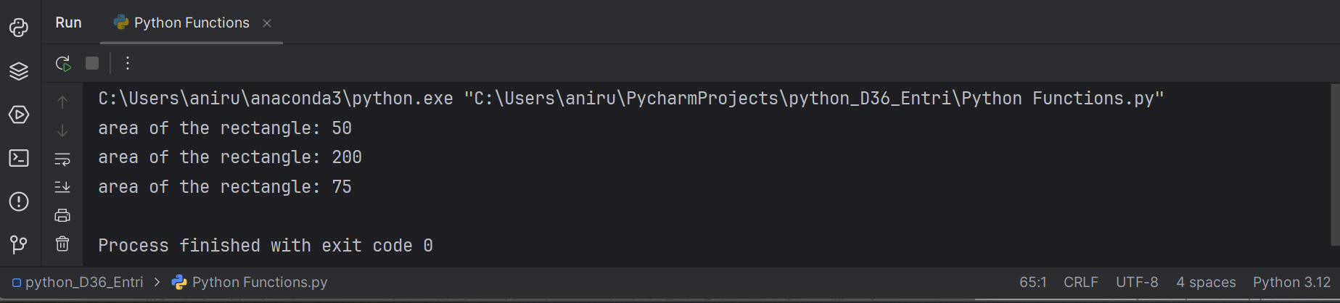

In the first call, calculate_area(10), the function uses the default value of width=5 and returns 10 * 5 = 50.

In the second call, calculate_area(10, 20), the function uses the provided value of width=20 and returns 10 * 20 = 200.

This demonstrates how the function behaves when called with and without the width argument. The default value of width=5 is used when the argument is not provided.